Are you taking advantage of all your opportunities to be happy? (435 words)
By Bob ‘Idea Man’ Hooey
"I don't know what your destiny will be, but one thing I do know, the only ones among you who will be really happy are those who have sought and found how to serve." Albert Schweitzer
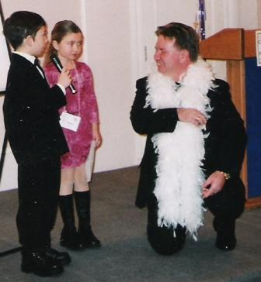
Are you happy in your career or business? Does it show?
Many of us miss amazing opportunities to bring a little joy into the lives of our customers, and through that ourselves, when we forget why we are in business. I tell my audiences that, "the main purpose of business is to make the lives of our customers better, at a profit."
I had the privilege of sharing these and other thoughts for Edmonton's Business Link a few years back. We broke new ground as we video cast this presentation to 17 other centres across Alberta and Sask.
When we are too focused on the daily challenges of dealing with conflicting demands, customer quirks and the hectic pace in which we live and do business, it is easy to forget. We lose the joy and zeal we had when we first started. This is a downward spiral making life more difficult and our relationships less satisfying. This spiral can be easily halted and reversed. It's a matter of perspective and choice!
Our success in business and life is built on relationships. Those relationships are enhanced and enriched when we reach out and touch people. I had the opportunity to visit with my friend Eric Chester, CSP when he was presenting here in Edmonton. Eric is the authority on dealing with Generation Why? He has a new book out "Getting them to give a damm" that we'll be reviewing in the future.
"There is a great paradox in reaching out to touch someone - and that is, the more you reach out to others, the more you will be touched yourself. Joy and happiness in great measure are waiting for us if we will reach just a little further," writes Joan Rawlusyk
My challenge for you is to make a conscious effort to reach out and touch the people that come into contact with your life personally and in your business. Be open to sharing joy and happiness in what you do.
If you're curious about the kids in this picture... a few years ago I had the great opportunity to work with two delightful grade 3 students - Astounding Announcers, who were introducing the speakers (including me) at a CAPS Edmonton event I was hosting. They were so much fun and a joy to work with... and they were very good too! Got me inspired to push myself in polishing my craft.
© Copyright 2015 Bob ‘Idea Man’ Hooey www.ideaman.net www.BobHooey.training
All rights reserved. Used with permission of the author.

Bob ‘Idea Man’ Hooey is a creative, productivity and leadership strategist who regularly writes for North American Consumer and Trade Journals, on-line magazines and company intranets. He works with Canada’s 50 Best Managed Companies. He is the prolific author of multiple business and leadership books and the 48th person in the history of Toastmasters International to earn their coveted professional level Accredited Speaker designation.

Articles may be copied or used for non-profit purposes, without the consent of the author, subject to the following being included: © Copyright 2015 Bob ‘Idea Man’ Hooey www.ideaman.net www.BobHooey.training All rights Reserved. Used with permission of the author.

